Gaidge Jellick
SNHU
CS - 499 - Computer Science Capstone
5/19/26

For this milestone, I made enhancements to my Weight Tracking application from CS-360. I wanted to change how the information on the weight/date was prompted, so I made adjustments to the code in order to fix the appeal of the data. Attached is an image of the new and updated look of how the Data Table is displayed vs how is used to be displayed.

Old | New
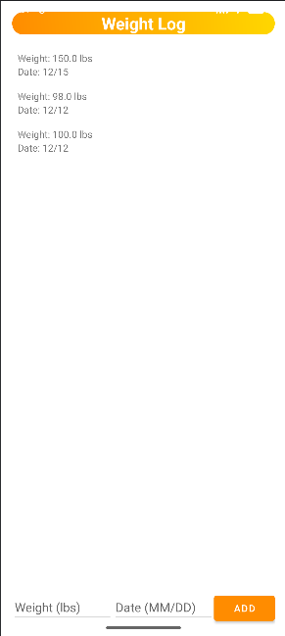 | 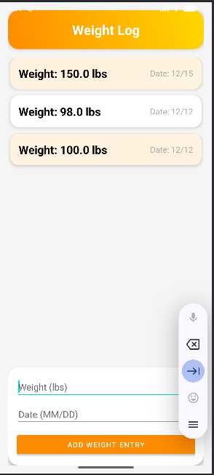

Now, to go over the changes I made.

Within Activity_Data.xml:
I didn’t change too much, just made the button for the input a little bit cleaner, as well as fixed some spacing issues. I did this by adding a new, more modular section to the code called MaterialCardView, which draws on Android's material library and creates a card view for the weight and date entry. The same was done for the actual display of the data after being entered as well.

Within WeightAdapter.java:
I added the imports for annotation and RecyclerView because I did not have them previously. I then called the new cardWeight method in the WeightViewHolder class that I had previously. I then gave my build viewer a simple if/else to make it change the color of the card based on whether it is even or odd.

